**Pokhara University**

**Nepal Engineering College**



A proposal on

**[Project Title]**

Submitted by:

[Full Name: Student] [CRN]

Biplov Paneru(019-402)

Submitted to:

Department of Electronics and Communication Engineering

Nepal Engineering College

Bhaktapur, Nepal.

[Month, Year]March, 2022

# ACKNOWLEDGEMENT

*Acknowledge the persons from whom you have taken help during your work; not mandatory.*

# ABSTRACT

*Concise and clear summary of the goals, major activities or project approach, and anticipated results of the proposed project. Should be very well written and revised after the body of the proposal is written. Always keep in mind that a good abstract grabs the attention of reader.*

Table of Contents

ACKNOWLEDGEMENT ii

ABSTRACT iii

LIST OF FIGURES (if any) v

LIST OF TABLES (if any) vi

1 INTRODUCTION 1

1.1 Background and Statement of Problem 1

1.2 Objectives and scope 2

1.3 Applications 2

1.4 Overview of Proposal 2

2 LITERATURE REVIEW 3

3 METHODOLOGY 4

3.1 Basic Block Diagram 4

3.2 Algorithms 4

3.3 Assumptions (if any) 5

3.4 Hardware and software required 6

3.5 Expected Outputs 6

4 FEASIBILITY ANALYSIS 7

4.1 Schedule 7

4.2 Financial Plan 7

5 CONCLUSION 8

REFERENCES 9

Appendices 10

# 1 INTRODUCTION

## 1.1 Background

*Background entails the details on:*

* *Motivational factors to choose the problems that are going to be addressed in this project.*
* *Problem description and justify the need for the project.*

## 1.2 Objectives and scope

*Objectives are the statements of precise and measurable outcomes (in bulleted form).*

*Scope presents the boundary lines for the project work.*

## 1.3 Applications

*Application areas of your project(in bulleted form).*

## 1.4 Overview of Proposal

*This is an overview of proposal not the project. It shows the details on what the different chapters/sections of proposal are comprised of, in short.*

*(Not mandatory. Use this section only if your proposal or report is long)*

**Always page break for every new chapter and remember that you could only page break for new chapter.**

# 2 LITERATURE REVIEW

*Discussion and critically evaluating past and current research in your area and identify gap in the literature of your field of study that you intend to fill. Describe the methodologies that you have studied.It might be the description of the previous state of art designs similar to the project.*

*Please note that the citations/references are very important for this section since it basically focusses on the works of others (state of art works) rather than your original work.*

*(Related papers/ projects; at least two.)*

# 3 METHODOLOGY

*Describe the approach and methodologies used to address the problem.*

## 3.1 Basic Block Diagram

*Go for a high level block diagram.*

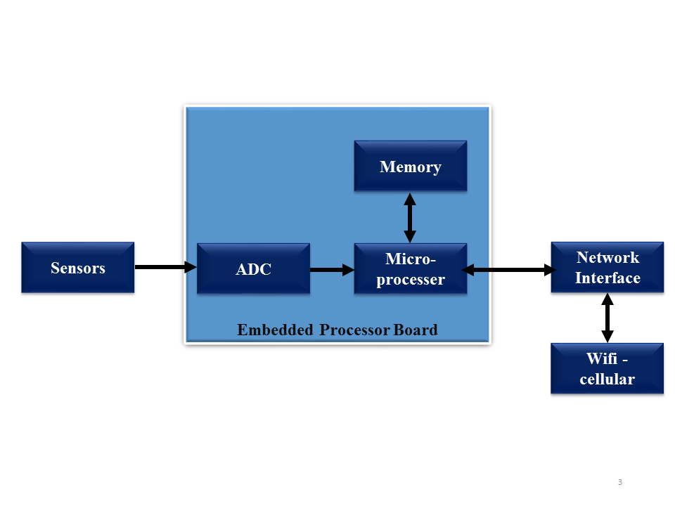

Figure 3.1 Block Diagram of System

*You may describe each block in detail. While going through each block, if needed the lower level associated blocks could be elaborated in details in each.*

*Please note that the block diagram should not be copied from any websites and should have been drawn using software tools like smartdraw, ms-visio etc.*

## 3.2 Algorithms

*Describe the algorithms that you will be implementing to solve the problem that you have stated.*

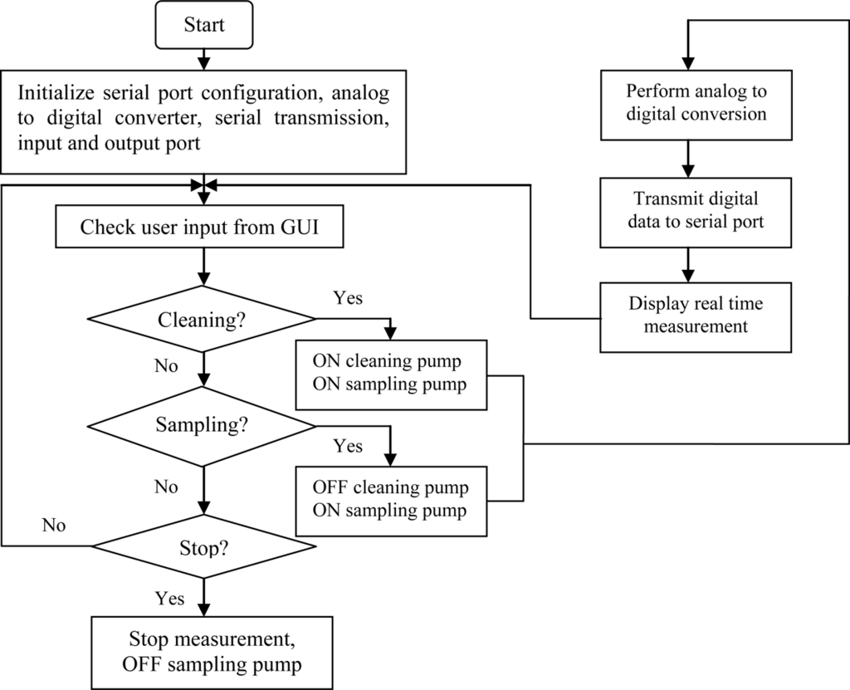

Figure 3.2 Flow chart of the overall system

*Please note that the flow chart should not be copied from any websites and should have been drawn using software tools like smartdraw, ms-visio etc.*

## 3.3 Assumptions (if any)

*Enumerate the assumptions that you have made for the project.*

## 3.4 Hardware and software required

*Describe your hardware and software that you will be needing in brief. Details on the basic hardware/software (for e.g. resistor/capacitor etc for hardware and windows for software) shouldn't be described.*

*You may include:*

* *Basic features of the component/software.*
* *Define the reason why you choose these component/software*
* *Interfacing circuit if you have any.*

## 3.5 Expected Outputs

*Expected output or deliverables of your project work.*

# 4 FEASIBILITY ANALYSIS

*State why your project is feasible in terms of economy, time etc*

## 4.1 Schedule

*This section defines the feasibility of the project in terms of time. Estimate the duration of your project, and identify order in which activities should be performed. Please explore the possibility of the use of software like smartdraw, for Gantt Chart.*

Table 4.1 Gantt Chart

|  |  |  |  |  |
| --- | --- | --- | --- | --- |
| S.N. | Tasks | Month | | |
|  |  |  |  |  |
|  |  |  |  |  |
|  |  |  |  |  |
|  |  |  |  |  |

## 4.2 Financial Plan

*This section defines the feasibility of the project in terms of economy. A line-item budget to support the project costs, including any cost sharing or program income.*

Table 4.2 Cost Estimation

|  |  |  |  |
| --- | --- | --- | --- |
| S.N. | Item | Cost per unit | Total Cost |
|  |  |  |  |
|  |  |  |  |
|  |  |  |  |
|  |  |  |  |

# 5 CONCLUSION

*Description of expected benefits of the proposed project and re-emphasize context and value of proposed project.*

# REFERENCES

1. Keller, T. E., Cusick, G. R., & Courtney, M. E. (2007). Approaching the transition to adulthood: Distinctive profiles of adolescents agingout of the child welfare system. Social Services Review, 81, 453-484.
2. Alexie, S. (1992). The business of fancydancing: Stories and poems.Brooklyn, NY: Hang Loose Press.

*[Please follow the APA format for referencing and citation. Please use following link to obtain APA format,*[*http://web.calstatela.edu/library/guides/3apa.pdf*](http://web.calstatela.edu/library/guides/3apa.pdf) *]*

# Appendices

* *Complete Circuit diagram*
* *PCB Diagrams (if any)*
* *Datasheets (only of special components used – if any)*